Day-3 Assignment

Name: E.R Harish

**SubTotal**

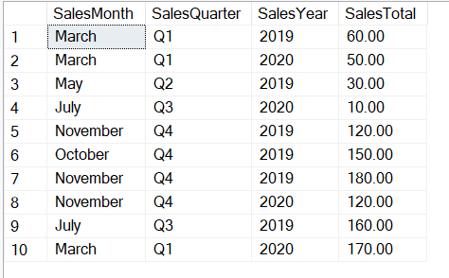

1. Using ROLLUP to Calculate Subtotals and Grand Totals

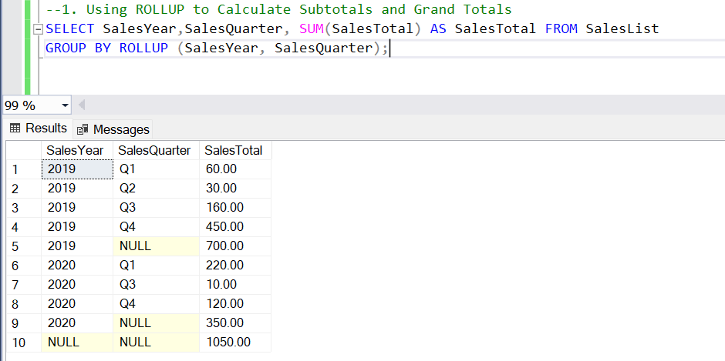

1. Replacing NULL Values with Labels for Subtotals and Grand Totals

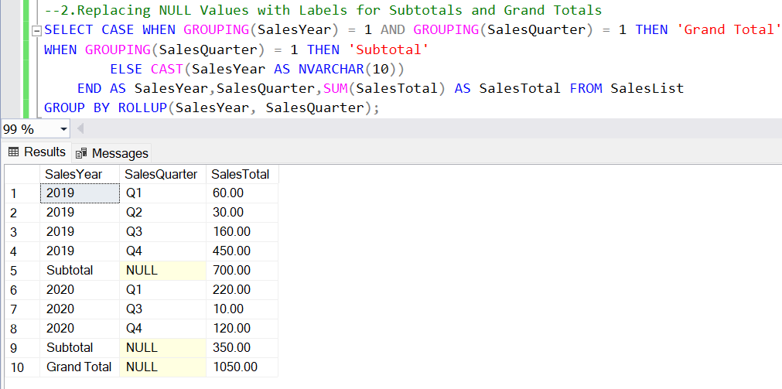

1. Using GROUPING SETS for Custom Subtotals

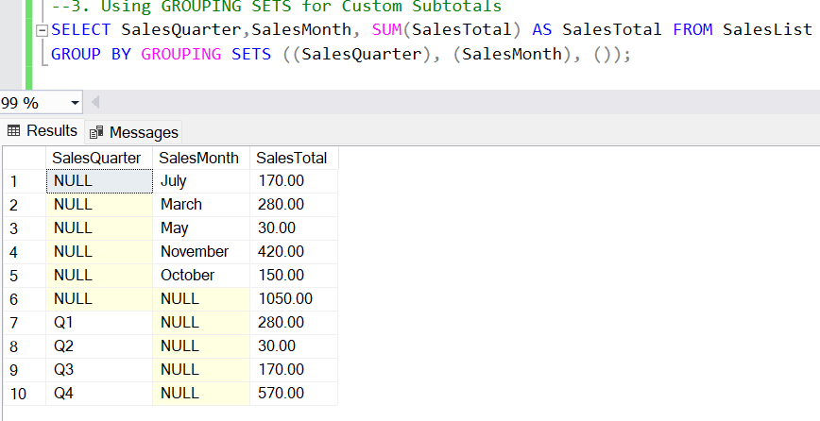

**Stored Procedure**

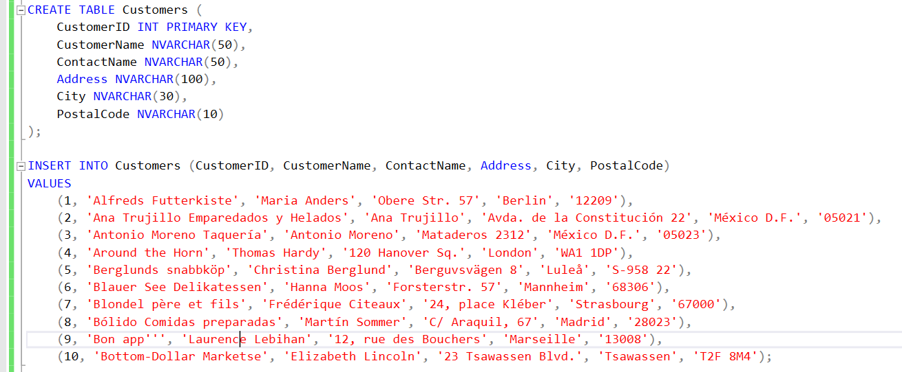

1. Create a Stored Procedure

CREATE PROCEDURE SelectAllCustomers AS SELECT * FROM Customers;

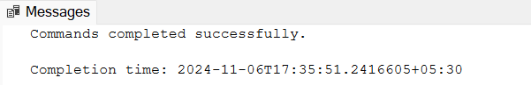

1. Execute the Stored Procedure

EXEC SelectAllCustomers;

